Lesotho

## Political Stability Estimate Data

The data set shows the political stability estimate of the country each year.

## # A tibble: 19 x 5  
## country iso3c date stability stabilityCategory4   
## <chr> <chr> <dbl> <dbl> <chr>   
## 1 Lesotho LSO 1996 0.232 moderately stable   
## 2 Lesotho LSO 1998 -0.119 moderately unstable  
## 3 Lesotho LSO 2000 0.0951 moderately stable   
## 4 Lesotho LSO 2002 -0.0473 moderately unstable  
## 5 Lesotho LSO 2003 0.0997 moderately stable   
## 6 Lesotho LSO 2004 0.358 moderately stable   
## 7 Lesotho LSO 2005 -0.00437 moderately unstable  
## 8 Lesotho LSO 2006 -0.126 moderately unstable  
## 9 Lesotho LSO 2007 -0.391 moderately unstable  
## 10 Lesotho LSO 2008 -0.206 moderately unstable  
## 11 Lesotho LSO 2009 0.326 moderately stable   
## 12 Lesotho LSO 2010 0.457 moderately stable   
## 13 Lesotho LSO 2011 0.384 moderately stable   
## 14 Lesotho LSO 2012 0.274 moderately stable   
## 15 Lesotho LSO 2013 0.338 moderately stable   
## 16 Lesotho LSO 2014 -0.333 moderately unstable  
## 17 Lesotho LSO 2015 -0.308 moderately unstable  
## 18 Lesotho LSO 2016 -0.236 moderately unstable  
## 19 Lesotho LSO 2017 -0.248 moderately unstable

## Political Stability Estimate Plot

The plot shows the trends of stabilization and destabilization for the each country.

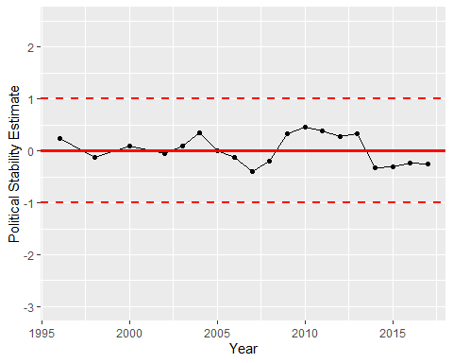

Political Stability Trend